  - Process
  - Definition
  - Document
  - Sample

  - Document History
Date | Version | Role | Name | Comment
 | 1.0 | Business Analyst |  | Created initial draft
Contents
I. Introduction 3
1.1. Purpose 3
1.2. Objectives 3
1.3. Process key contacts 3
1.4. Minimum prerequisites for the automation 4
II. As-is process description 4
2.1. Process overview 4
2.2. Applications used 5
2.3. As-is process map 5
2.3.1. High-level process map 5
2.3.2. Detailed level process map 6
2.4. Detailed as-is process actions 6
III. To-be process description 6
3.1. Detailed to-be process map 6
3.2. Input/Output data description 6
3.3. Exceptions Handling 7
3.4.1. Known business exceptions 7
3.4.2. Unknown business exceptions 7
3.4. Applications errors and exceptions handling 7
3.5.1. Known applications errors and exceptions 7
3.5.2. Unknown applications errors and exceptions 8
3.5. Reporting 8
3.6. In scope for automation 8
3.7. Out of scope for automation 8
3.8. Change/Improvement details 9
IV. Other 9
4.1. Additional sources of process documentation 9
4.2. Change requests 9
4.3. Document approval 10

Introduction

Purpose
The purpose of the As-Is process is to define how vendor invoices are currently managed within Acme System 1, from retrieval and data extraction to validation and completion or rejection. It sets the baseline workflow to highlight existing manual steps, decision points, and potential bottlenecks that impact efficiency. This purpose provides a clear reference point for identifying areas where automation can streamline the process, enhance accuracy, and reduce operational risks.

Objectives
The objective of the current vendor invoice handling process is to ensure that all incoming invoices are properly validated, processed, and recorded in Acme System 1. The process aims to verify the accuracy of invoice data, confirm vendor legitimacy, and maintain updated work item records by either completing or rejecting invoices. Once this process becomes automated, it will bring significant benefits: reduction of manual effort, elimination of human errors during data entry, faster turnaround time for invoice handling, and improved scalability to handle larger volumes without additional workforce. Automation will also improve compliance by ensuring consistent application of business rules and exception handling .
Objectives | Benefits
Improve the department’s overall performance and reliability | educe human error by miscalculation and copying wrong data
Speed up the invoice processing cycle | Faster extraction and validation of invoice details compared to manual handling
Ensure accuracy and consistency in data entry | Automated data capture eliminates inconsistencies between invoices and system records
Enhance compliance with business rules | Automated vendor validation ensures only approved vendors are processed
Increase process scalability | Ability to handle high volumes of invoices without adding extra workforce
Reduce operational costs | Lower dependency on manual workforce and time spent on repetitive tasks
Improve exception handling and monitoring | Automated logging and categorization of errors for faster resolution

Process key contacts
The specifications document includes concise and complete requirements of the business process, and it is built based on the inputs provided by the process Subject Matter Expert (SME)/ Process Owner.
The Process Owner is expected to review it and provide signoff for accuracy and completion of the steps, context, impact, and complete set of process exceptions.
The names have to be included in the table below.

Role | Name | Contact Details
Business Analyst | Youssef Kamel | Youssefmk1214@gmail.com
Process SME / Process reviewer | Mohamed Mesbah | Mohamed.mesbah@rackist.com

Minimum prerequisites for the automation
- Filled in Process Definition Document
- Test Data to support development.
- User access and user accounts creations (licenses, permissions, restrictions to create accounts for robots)
- Credentials (user ID and password) required to log on to machines and applications.

As-is process description

Process overview
The current As-Is process for handling vendor invoices in Acme System 1 is a repetitive and semi-manual workflow. It begins with logging into the system, navigating to open work items, and downloading invoice PDFs to extract details such as vendor name, tax ID, and totals. The process then involves validating whether the vendor exists in the system; if the vendor is found, the extracted invoice data is entered into the form fields, comments are added, and the work item is marked as completed. If the vendor does not exist, the work item is marked as rejected with a comment. The process includes a loop where the system checks for more items, waits 30 minutes if none are found, and continues until work hours are exceeded, at which point the process stops. Overall, the workflow is structured but relies heavily on manual steps such as PDF data extraction, vendor searches, and data entry, making it time-consuming and prone to inefficiencies .

Item | Description/Answer
Process Full Name | Vendor Invoice
Process Area | Financial
Department | Finance and Accounting
Short Description (operation, activity, outcome) | The process logs into Acme System 1, retrieves open work items, extracts invoice data from PDFs, validates the vendor, updates the work item as completed or rejected, and repeats until no items remain or work hours end .
Role(s) required in applications to perform the process | Accounts Payable
Process schedule and frequency | Daily, Monday to Friday, 9 am – 6 pm
Number of items per month | 4500
Average handling time per item | 10
Process Restrictions | e.g. This is necessary for the Solution Architect to decide how they will need to split the Master Project into smaller projects (the scheduling of the robots will depend on this)  Example: The applications can be used only between 7 AM-8PM during work days and not allowed to be used during weekend.
Peak Period (s) | End of month, usually from 20th to 28th day of each month
Peak Volume Approximate increase | 300
Total # of FTEs supporting this activity | 1
Expected Volume increase during next periods | 5 - 10 %
Input data description | invoice Data(Tax Id ,Vendor Name , Date , Invoice Id , Item Description , Currency , Subtotal , Tax Amount , Total)
Output Data description | Invoice Data Added

Applications used
The table includes a comprehensive list of all the applications that are used as part of the process to be automated to perform the given actions in the flow.

Application Name | Details (Version, Language, Environment/ Access method)
Any Browser SW | Used To open Acme System 1
Any Pdf Reader SW | Used To open Downloaded pdf

As-is process map

High-level process map
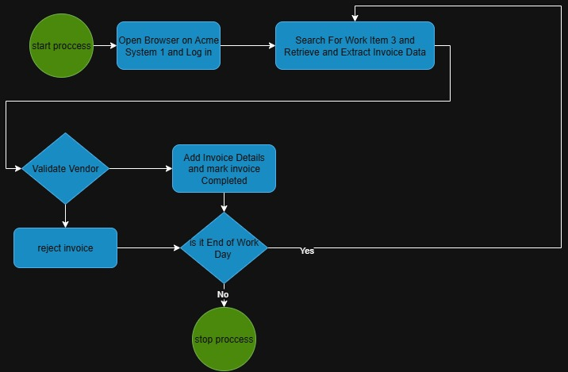

Detailed level process map
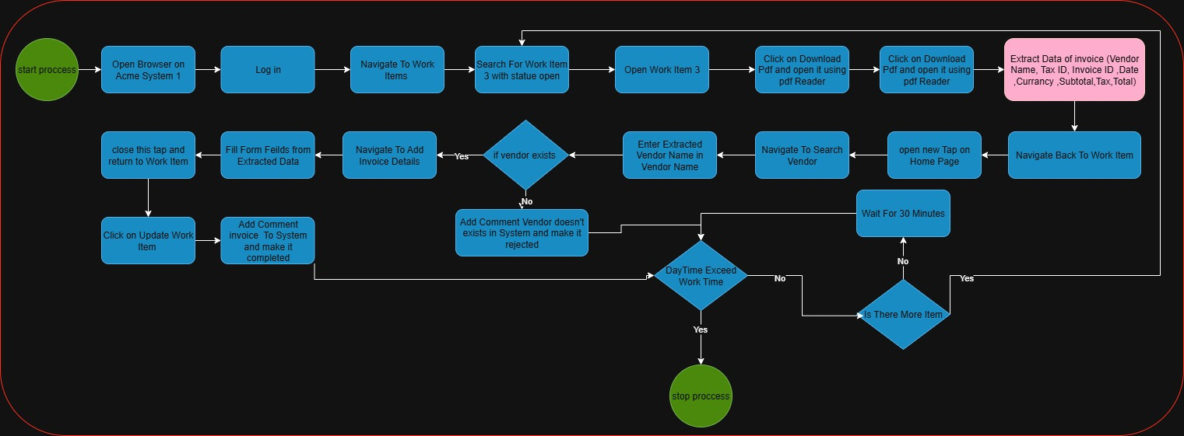

Detailed as-is process actions
# | Input | Description | Details | Exception Handling | Output
1 | - | Open Browser on Acme System 1 |  | AE01 | 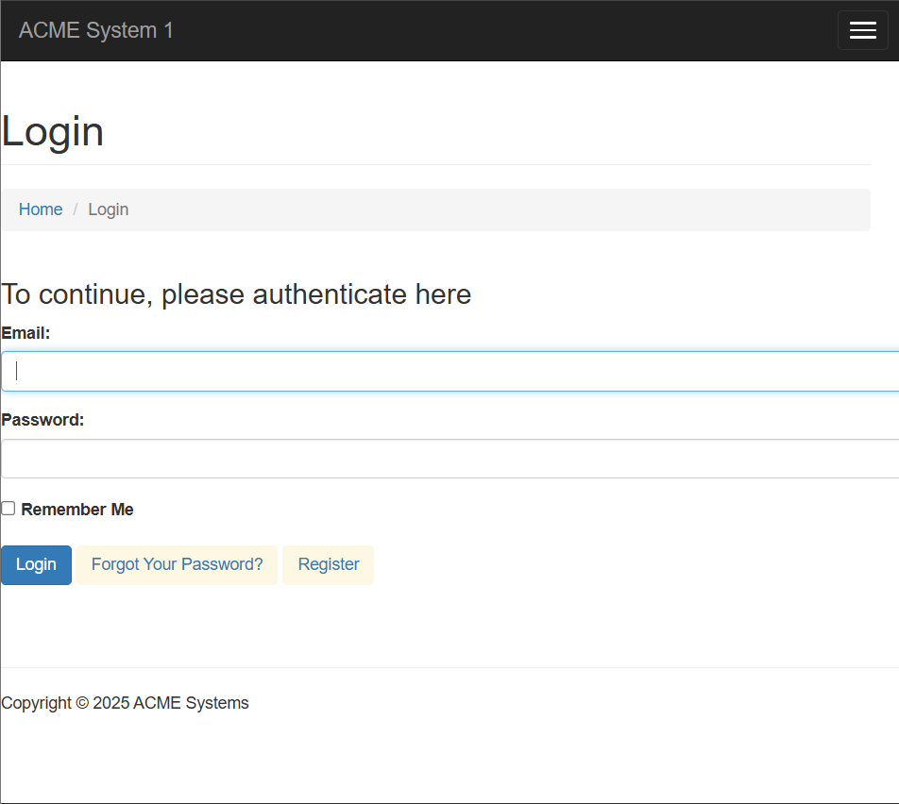
2 | Credentials | Login To Acme System 1 | 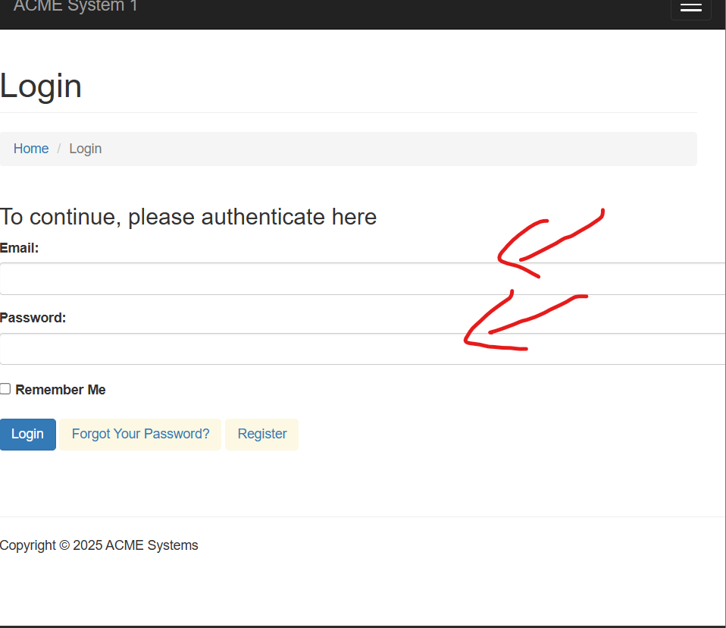 | AE03 | 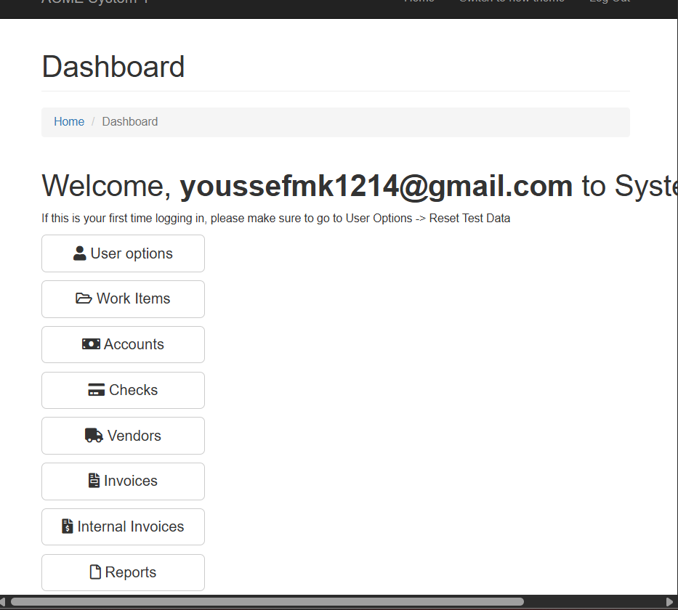
3 |  | Navigate To Work Items | 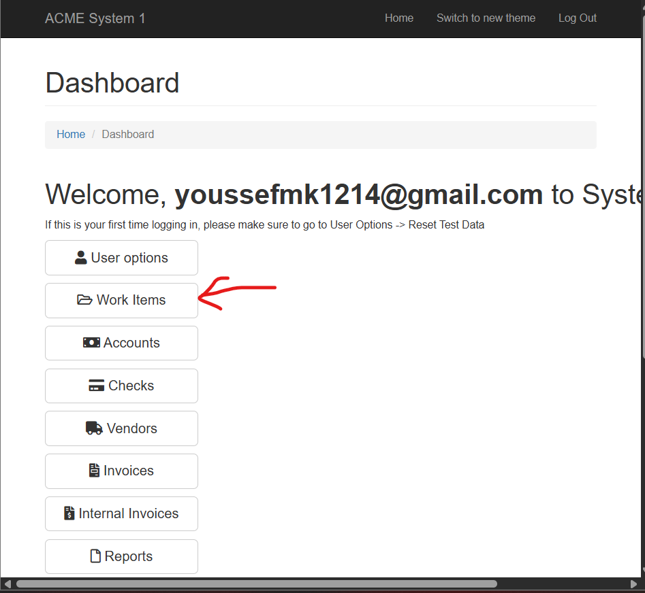 | BE06 | 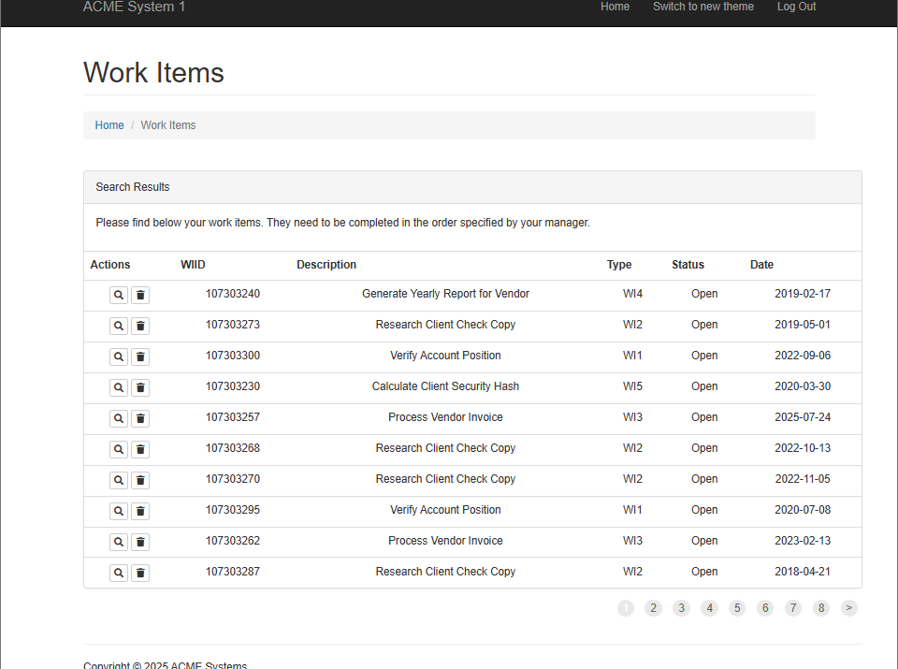
4 |  | Search For Work items 3 | 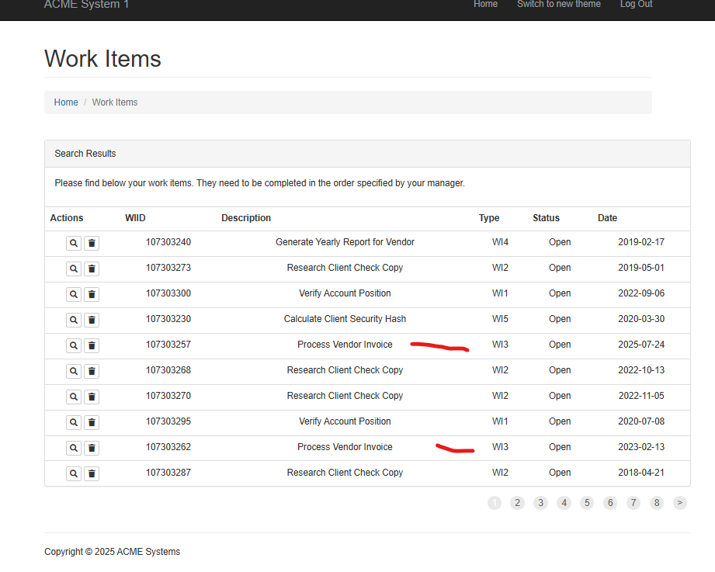 | BE06
5 |  | Open Work item 3 with statue open | 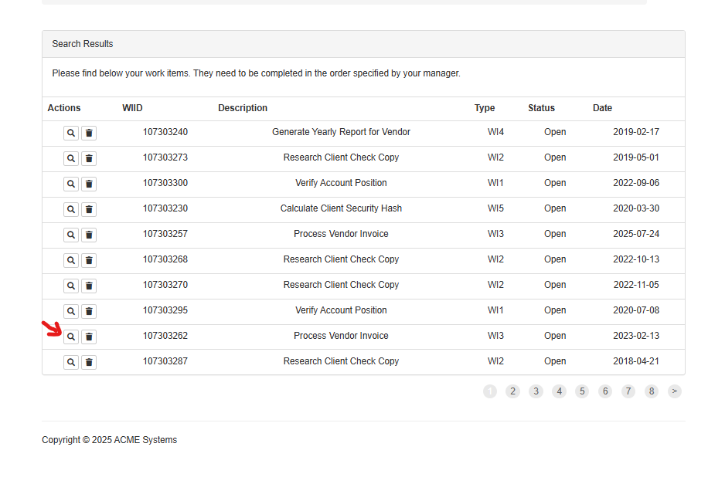 | AE05 | 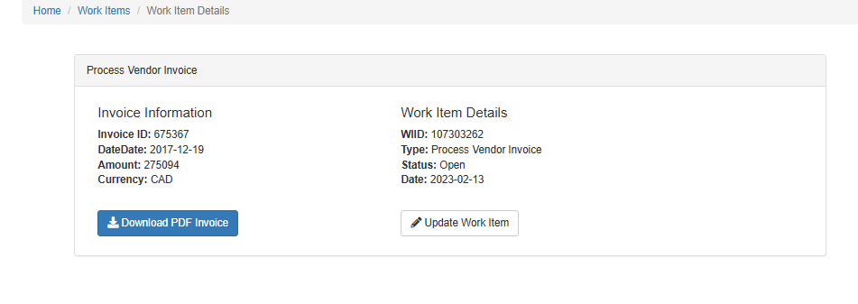
6 |  | Click on Download Pdf and open it | 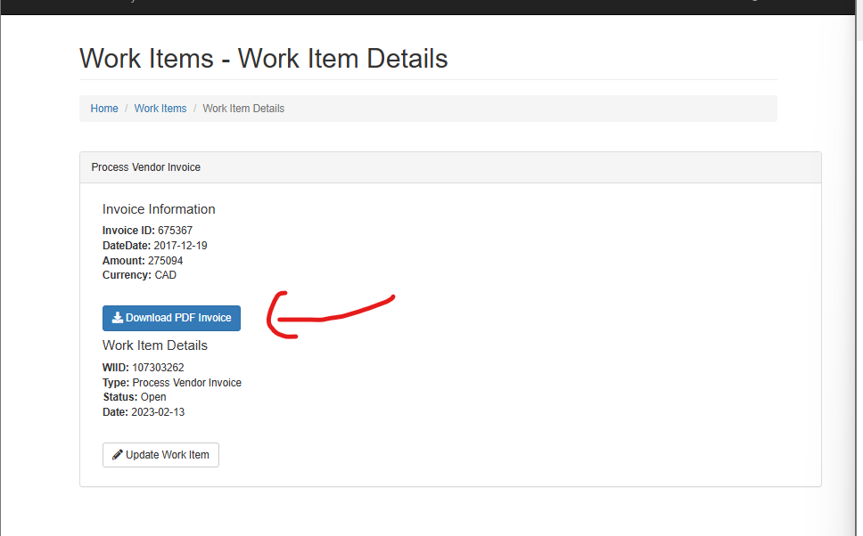 | AE04  or AE02 | Open item using Pdf Reader
7 |  | Extract invoice Data(Tax Id ,Vendor Name , Date , Invoice Id , Item Description , Currency , Subtotal , Tax Amount , Total) | 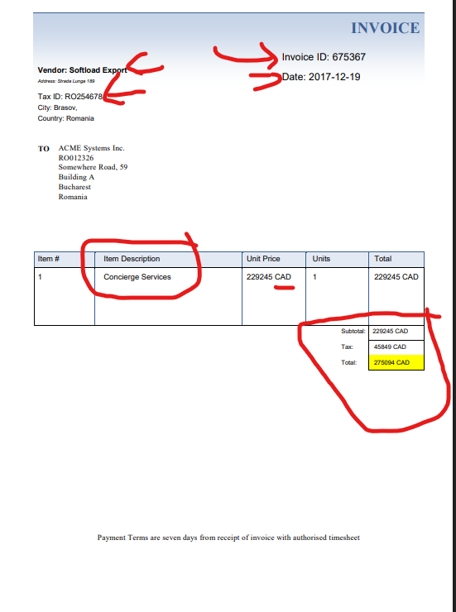 | BE04  or BE05  or AE06
8 |  | Navigate Back To Work Item |  | AE05
9 |  | Open new Tap Home Page and click on Search Vendors | 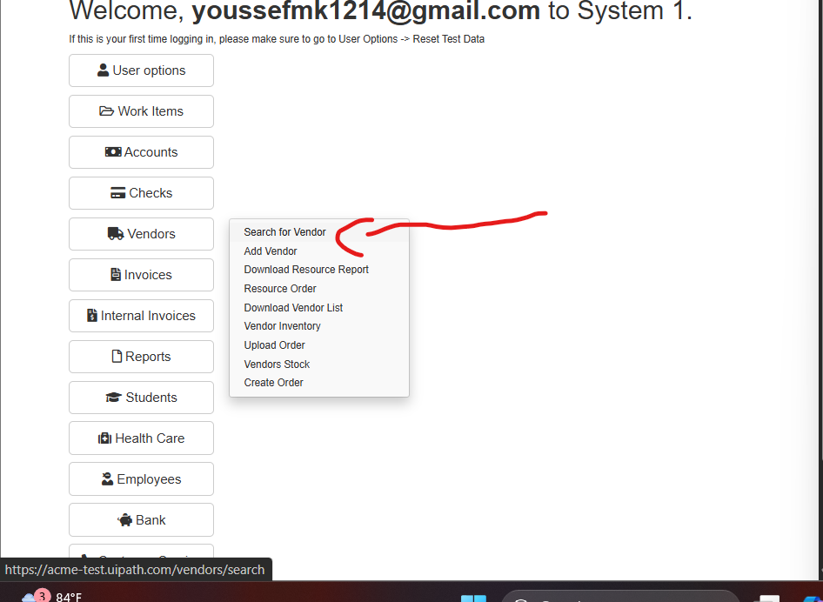 |  | 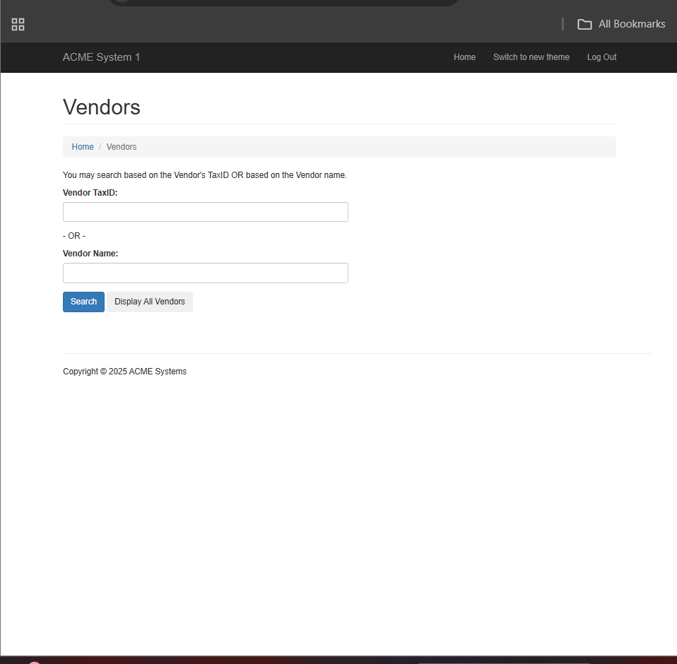
10 | Tax Id | Enter Tax Id on Vendor Tax Id Field | 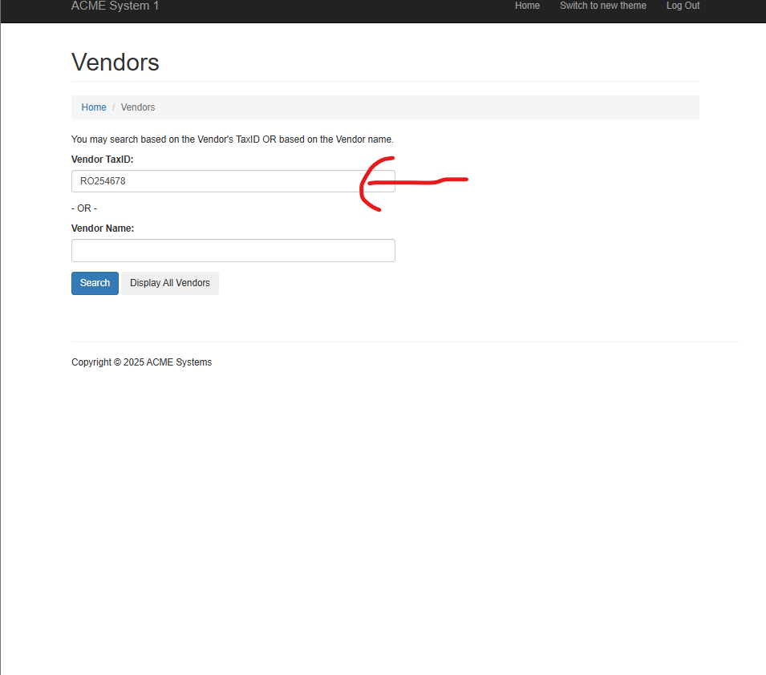 | BE08 | 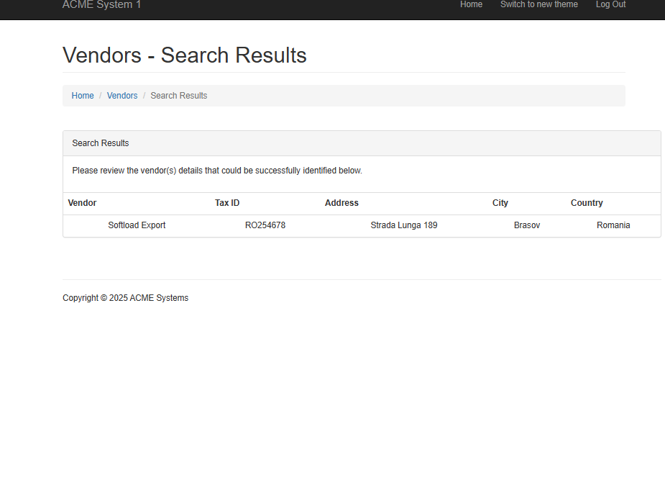
11 |  | Navigate Back To Home Page and click Search on Search Invoice | 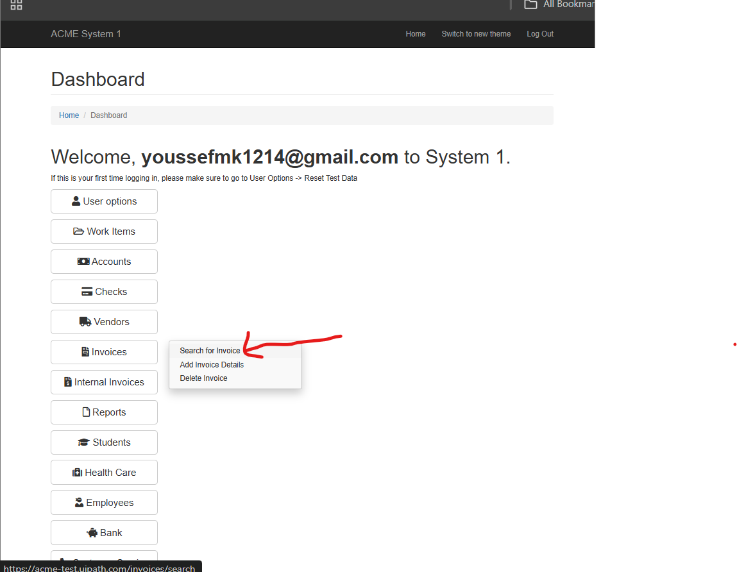 |  | 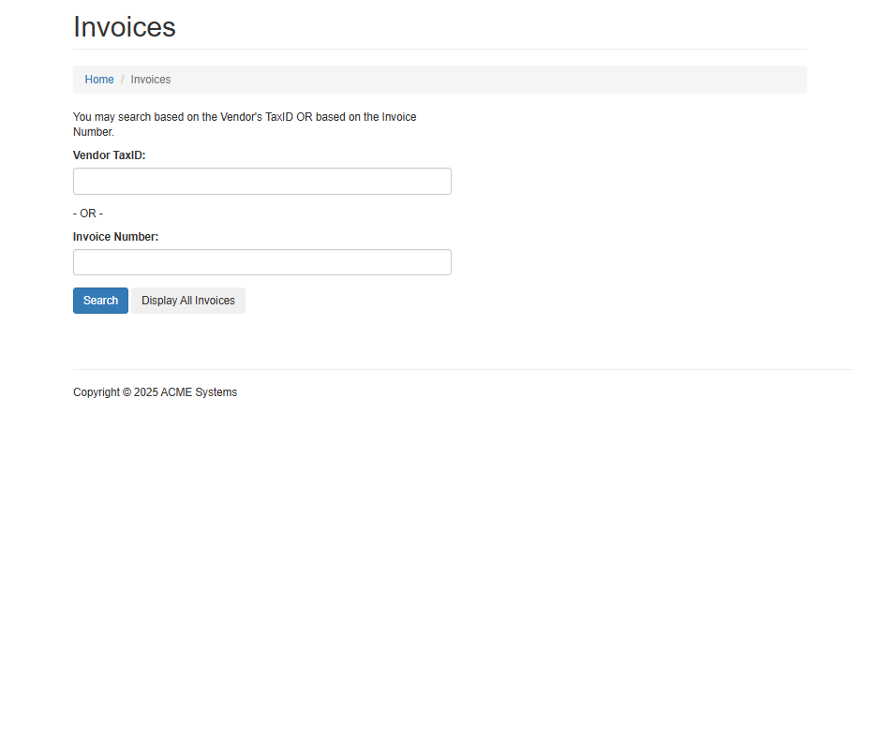
12 | Invoice id | Enter invoice Id in Invoice Number | 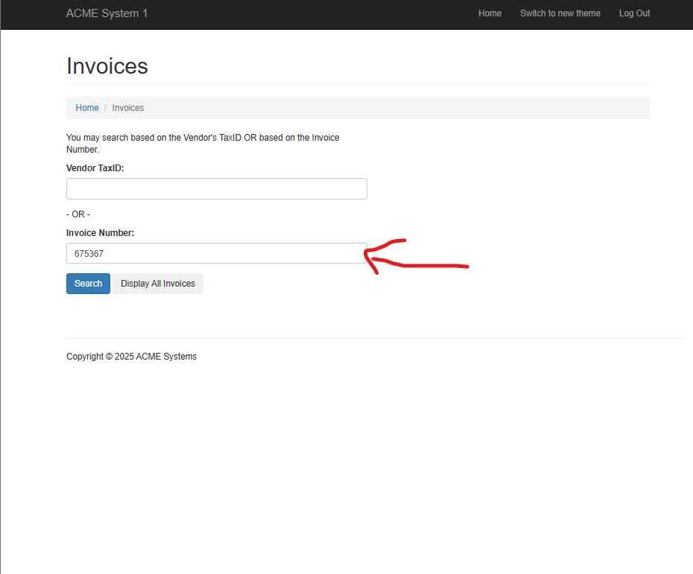 | BE03 | 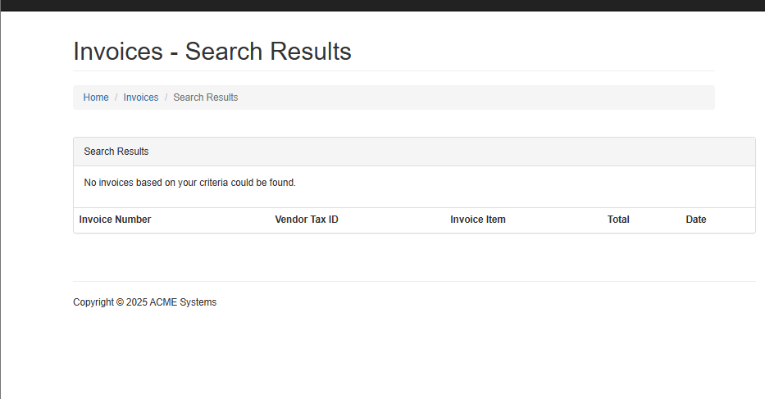
13 |  | Navigate Back To Home page and click on add invoice | 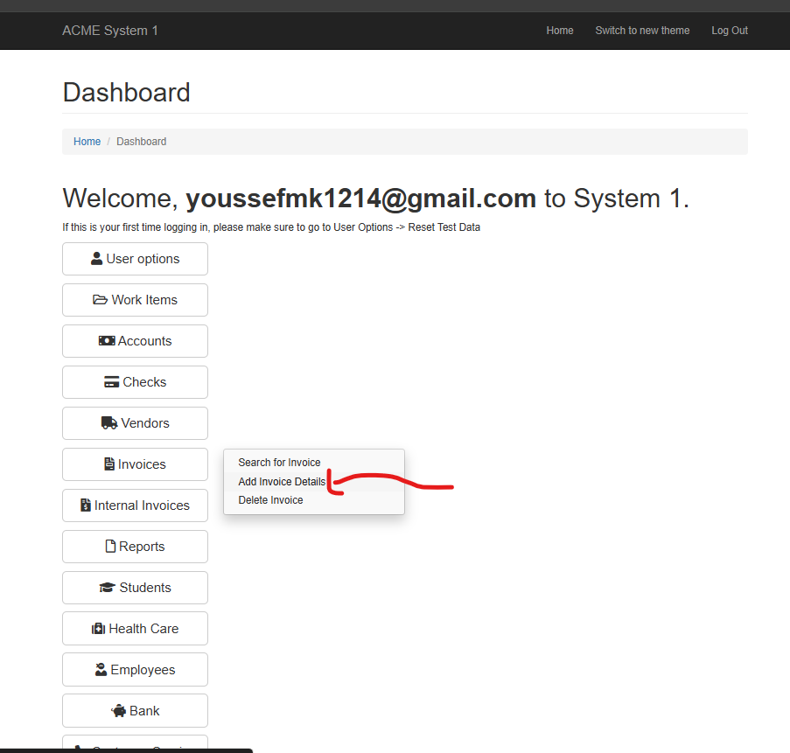 |  | 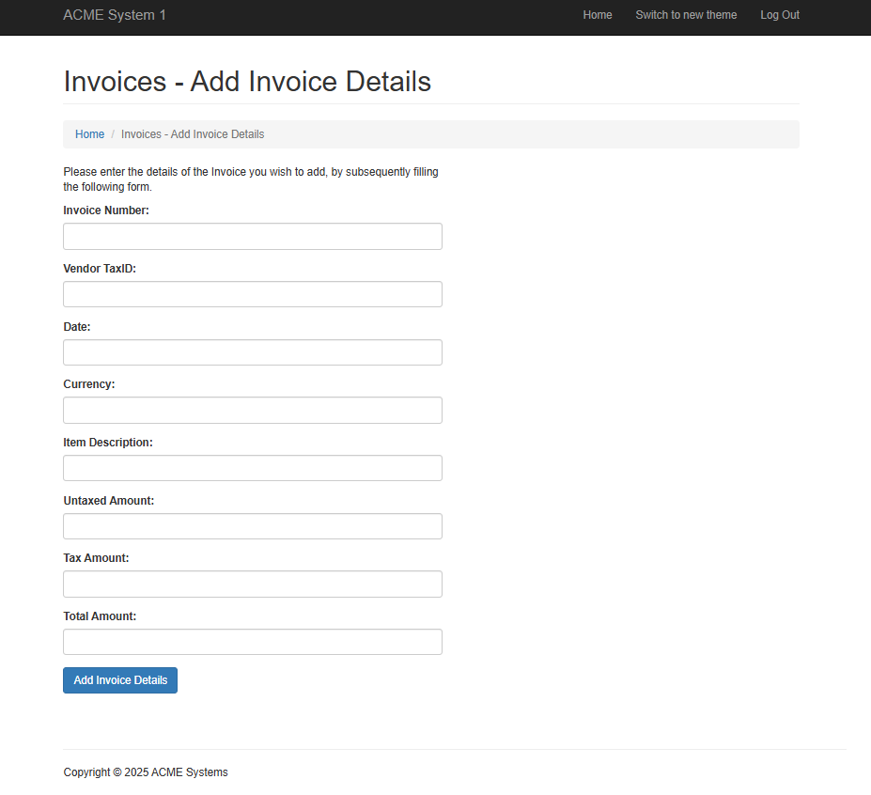
14 | Invoice Number,Tax Id,Date,Cuurency,subtotal(untaxed amount),  Tax Amount,  Total,  Description | Add invoice data and submit it | 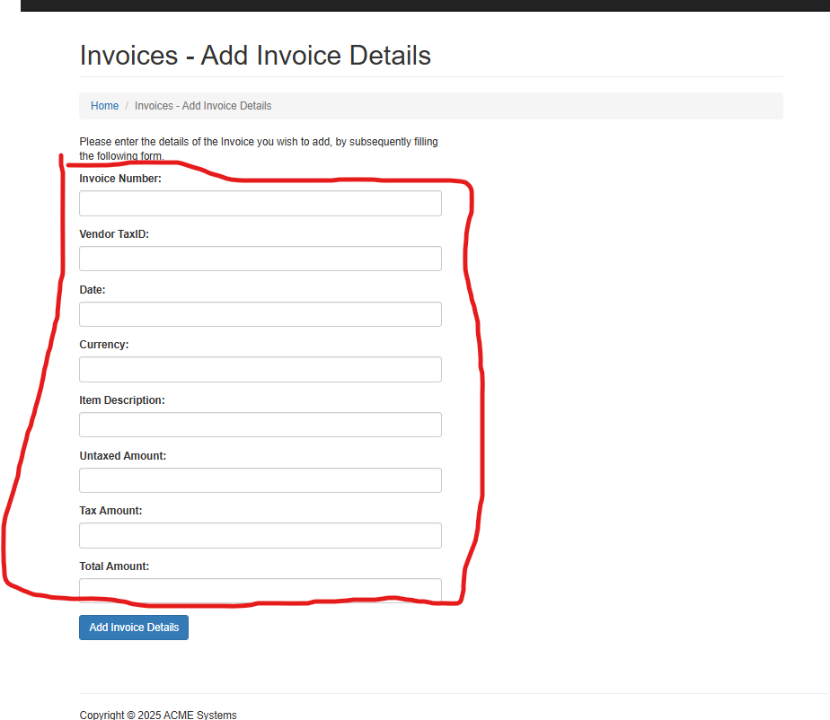 | AE07 | 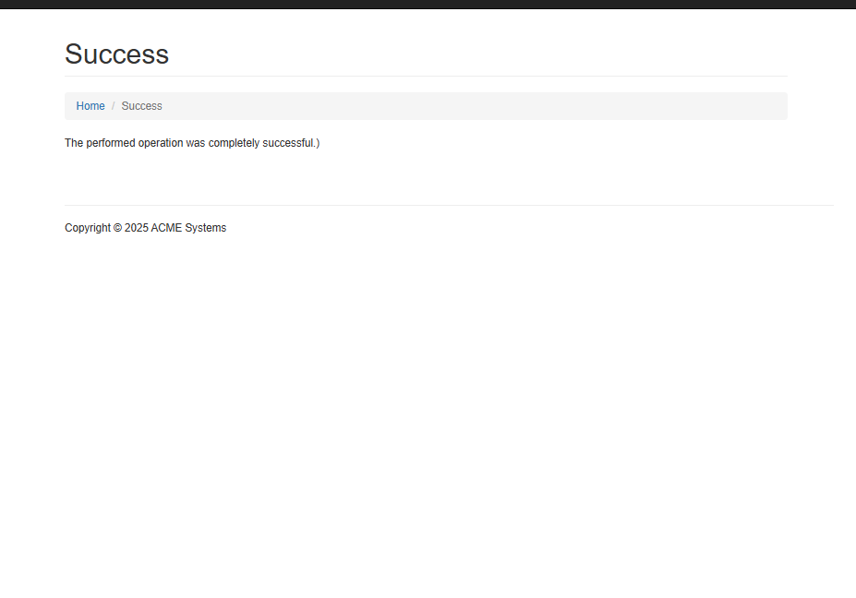
15 |  | Close This Tap and in Work Item Tap click on update item | 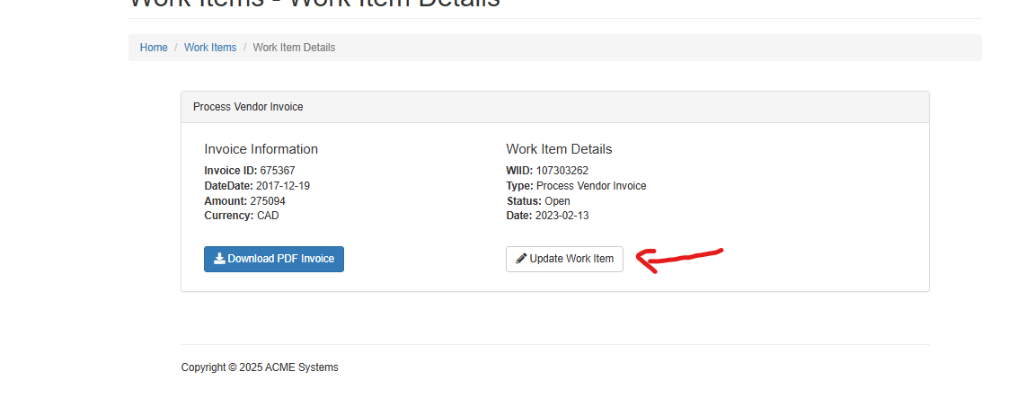 | AE05 | 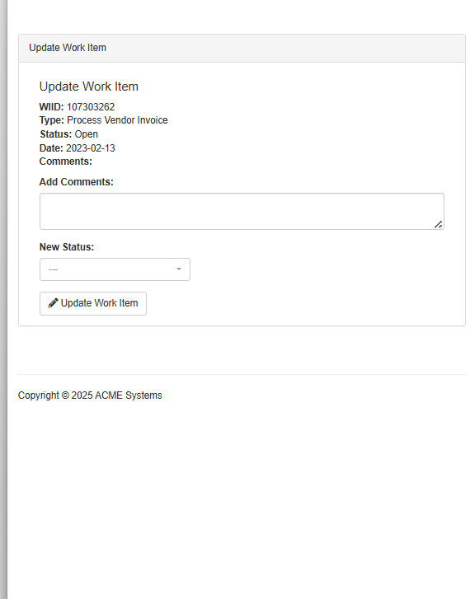
16 |  | Add comment Added To System and mark it as completed | 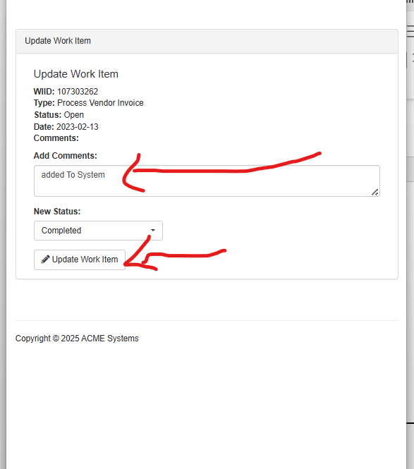 |  | 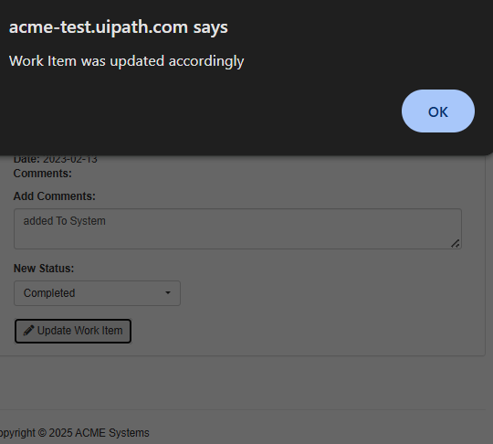
17 |  | Check if Time exceeds Work Day
18.Y |  | Yes it Exceeds | Stop Process
18.N |  | No it doesn’t | Navigate Back Work items page Repeat Steps again step 5:18

To-be process description

Input/Output data description

The following table should contain details regarding the inputs that every action of the process takes.

# | Sample | Type | Input/Output | Process step # | Storage location
1 | xxx@.com => credentials .email  aaaa => credentials .password | credentials(string) | input | 5 | Json File
2 | Invoice Pdf | Pdf file | Output&input | Output:6  Input:7 | Local Folder
3 | Tax Id | Number |  | Output:6  Input:10,14 | In Memory
 | Vendor Name | String |  | Output:6  Input:14
 | Date | Date |  | Output:6  Input:14
 | Invoice Id | Number |  | Output:6  Input:12,14
 | Item Description | String |  | Output:6  Input:14
 | Currency |  |  | Output:6  Input:14
 | Subtotal | Number Float |  | Output:6  Input:14
 | Tax Amount |  |  | Output:6  Input:14
 | Total |  |  | Output:6  Input:14

Exceptions Handling
The Business Process Owner and Business Analysts are expected to document below all the business exceptions identified in the automation process. Exceptions are of 2 types, and both need to be addressed:
- Known exceptions - previously encountered. A scenario is defined with clear actions and workarounds for each case.
- Unknown exceptions - New situation that was not encountered before. It cannot be predicted and in case it happens it needs to be flagged and communicated to an authorized person for evaluation.

Known business exceptions

# | Exception description | Action to be taken
BE01 | When validating vendor details, the vendor record is not found in the system | Reject the invoice, update the work item with a comment (“Vendor not found”), and mark status as rejected and send email To Director of Accounting
BE02 | Invoice fields such as Vendor Name, Tax ID, Invoice ID, or Date are missing or incorrect | Stop processing, reject the invoice, add comment explaining missing/invalid data, and update work item send email To Director of Accounting
BE03 | The invoice ID already exists in the system (possible double submission by vendor) | Reject the invoice, add “Duplicate invoice” comment in the work item, and notify business if needed
BE04 | The invoice is in a currency not handled by the system, or the invoice file is in an unsupported format (e.g., image instead of PDF) | Reject invoice, update work item with “Unsupported currency/format,” and notify finance team for manual follow-up
BE05 | Amount Mismatch (Subtotal + Tax ≠ Total) | Reject the invoice, document mismatch in comment, and update work item
BE06 | No Work Item in this page | Move To Next Page
BE07 | at last page no Work item found | if its not end of working day begin search again Move to first page and search for work items 3
BE08 | No Vendor Found after search Vendors | Reject the invoice, Vendor Doesn’t Exists in comment, and update work item as rejected and move To next work item send email To Director of Accounting

Unknown business exceptions
for all other cases which do not follow the rules defined an e-mail should be sent to: rpa_support@raya.it.com with a screen shot and robot should proceed to next transaction .

Applications errors and exceptions handling

Known applications errors and exceptions

# | Exception description | Action to be taken
AE01 | Web browser SW doesn’t open | Retry login up to 3 times; if still failing, log error, notify IT support, and Project Manger and Director of Accounting
AE02 | Pdf Reader cant open Pdf | Retry login up to 3 times; if still failing, log error, notify IT support, and Project Manger and Director of Accounting
AE03 | Acme System 1 login fails due to wrong credentials, downtime, or network issue | Retry login up to 3 times; if still failing, log error, notify IT support, and Project Manger and Director of Accounting
AE04 | Invoice PDF cannot be downloaded from work item due to broken link, corruption, or timeout | retry download 3 times; if unsuccessful, reject the invoice with “File not downloadable,” and escalate to support if recurring , notify Director of Accounting
AE05 | system navigation (opening work item, saving updates) fails due to session timeout or page load error | Refresh session/page, retry up to 3 times; if still failing, log exception and escalate to IT and Director of Accounting
AE06 | Acme System or PDF Reader crashes/freezes mid-process | Restart application/browser, resume from last stable step; if persistent, escalate issue to IT and Director of Accounting .
AE07 | Invoice details cannot be submitted (form error, database connection issue) | Retry submission 3 times; if still failing, log exception, add comment to work item, and escalate to IT and Director of Accounting .

Unknown applications errors and exceptions
.robot should attempt to access the application 3 times then it should terminate process and escalate to Project Manager and Director of Accounting and IT Team.

Reporting
In this section all the reporting requirements of the business should be detailed so that when the automation solution is moved to production the administrators can track the performance of the solution.

Report Type | Update frequency | Details | Monitoring Tool to visualize the data

In scope for automation
All process Steps are in scope of Automation.

Out of scope for automation
All process Steps are in scope of Automation .

Change/Improvement details
Use this section to detail the list the change or improvement opportunity in the To-Be Process.
Important aspects to be mentioned: what is the initiative, expected outcome, expected completion date, contact person for details, and if will impact the current automation request.

# | Initiative Name | Process Action(s) where it is identified | Impact on current Automation Request | Expected Completion Date | Contact Person

Other

Additional sources of process documentation
Item | Location
Video Recording of the process (Optional)
Business Rules Library (Optional)
Other documentation (Optional)
Standard Operating Procedure(s) (Optional)
High Level Process Map (Optional)
Detailed level process map (Optional)
Work Instructions (Optional)
Input Files (Optional)
Output Files (Optional)

Change requests
# | Date | Change description | Affected process steps / section | Change reason | Change initiator

Document approval

